 *Faculty of Engineering and Technology*

*Electrical & Computer Engineering Department*

*First Semester, 2022/2023*

*Computer Architecture ENCS4370*

***First Project***

***Text Message Encryption and Decryption***

*Prepared by:*

*Sara Ammar 1191052*

*Al Ayham Maree 1191408*

*Supervised by:*

*Dr.* [*Aziz Qaroush*](https://ritaj.birzeit.edu/bzu-msgs/type?mttid=104&classid=196326)

*Section:*

*2*

*Date:*

*29-12-2022*

# Overview

This project is a MIPS program that does a simple encryption/decryption algorithm based on the English-based Caesar Text Messages encryption algorithm. In Caesar cipher, the message is hidden from unauthorized readers by shifting the letters of a message by an agreed number. It uses the substitution of a letter by another one further in the alphabet. Upon receiving the message, the recipient would then shift the letters back by the same number agreed upon earlier. In this program, the encryption key is the longest word in the message, so the character shift is the amount of this key.

# Test Cases

## Test case 1:

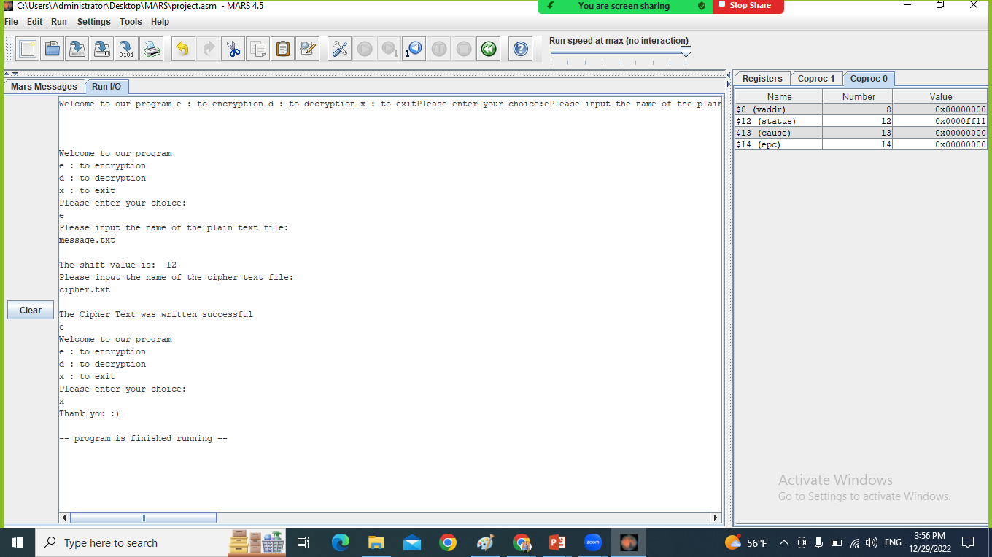

Figure : Encryption test

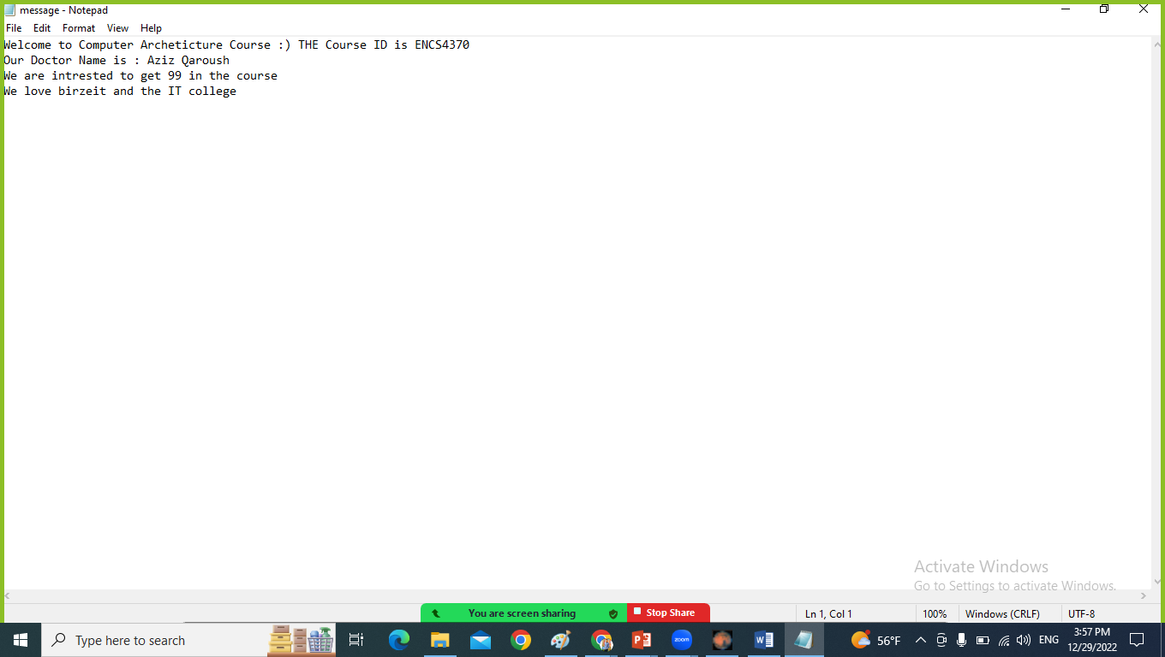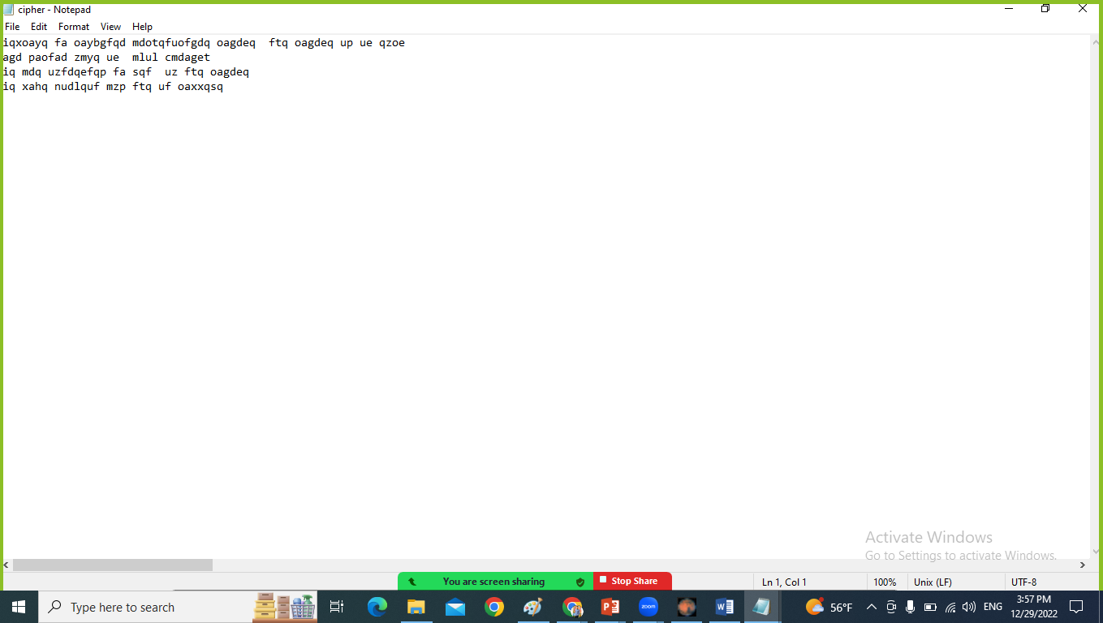

Figure 2: Input message and output Cipher

The shift value from above is: 12 (length of Architecture word).

## Test case 2:

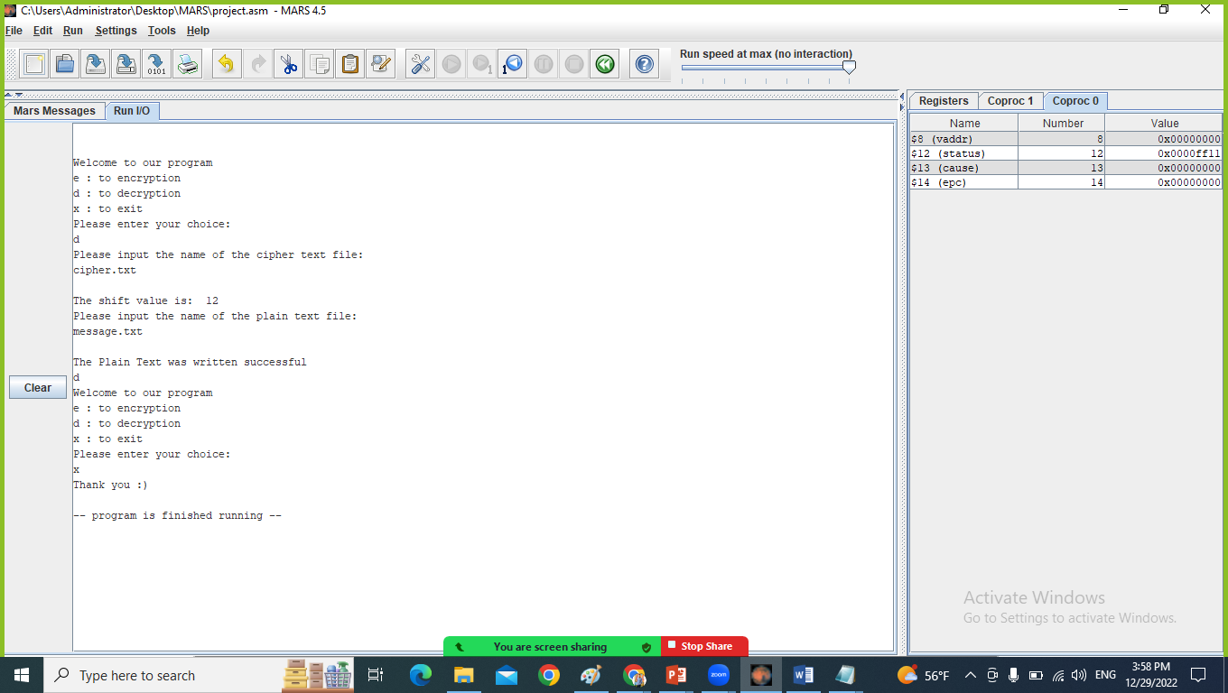

Figure 3: Decryption test

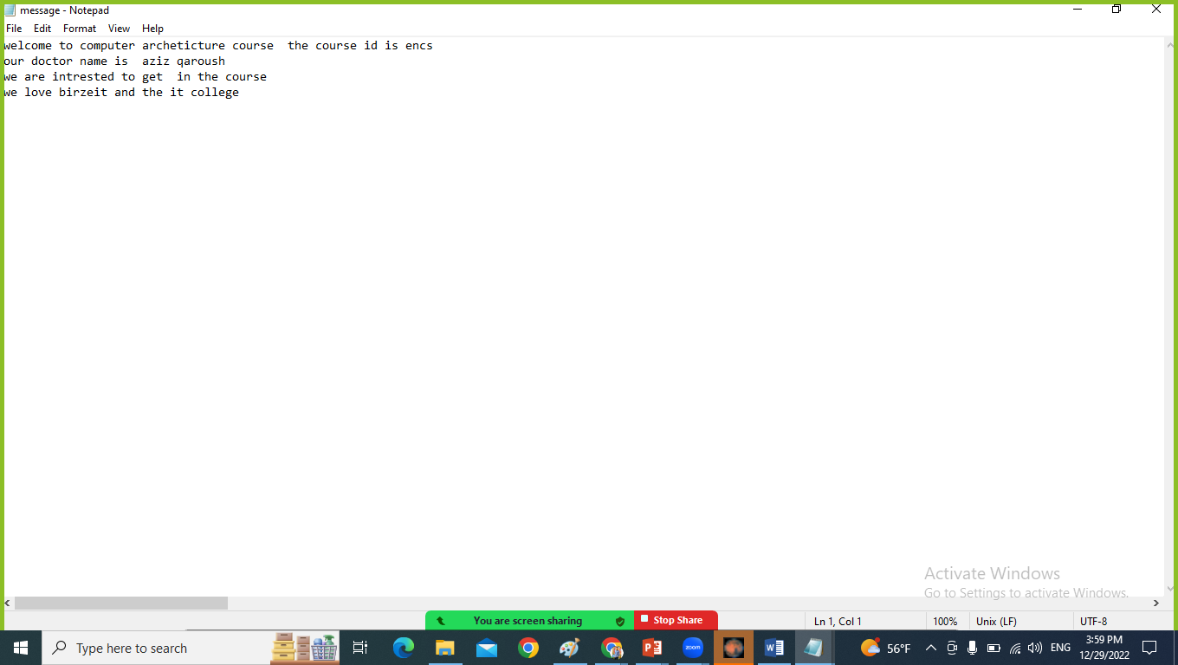

Figure 4: Input Cipher and output message

The shift value from above is: 12 (length of mdotqfuofgdq word).

## Test case 3:

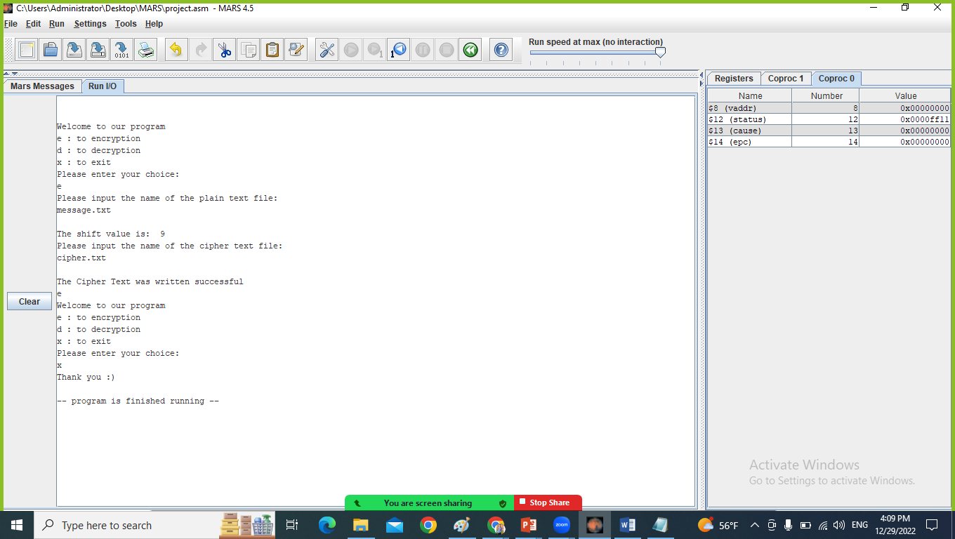

Figure 5: Encryption test

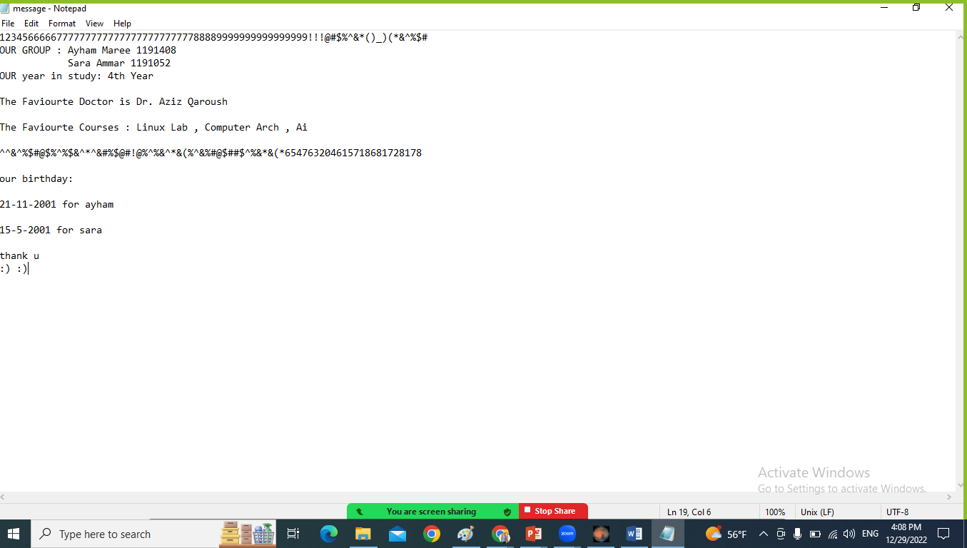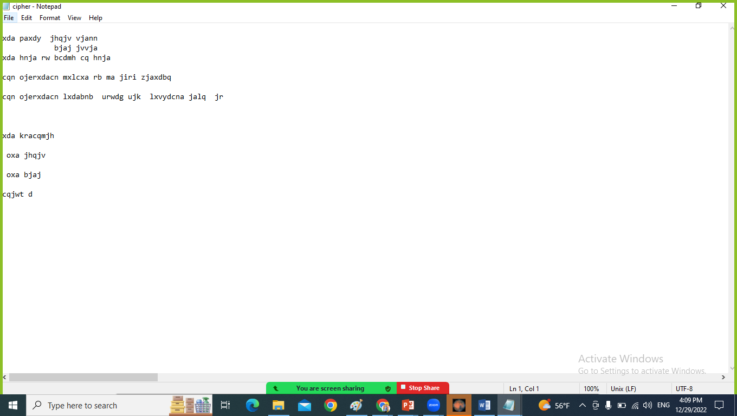

Figure 6: Input message and output Cipher

The shift value from above is: 9 (length of Favourite word).

## Test case 4:

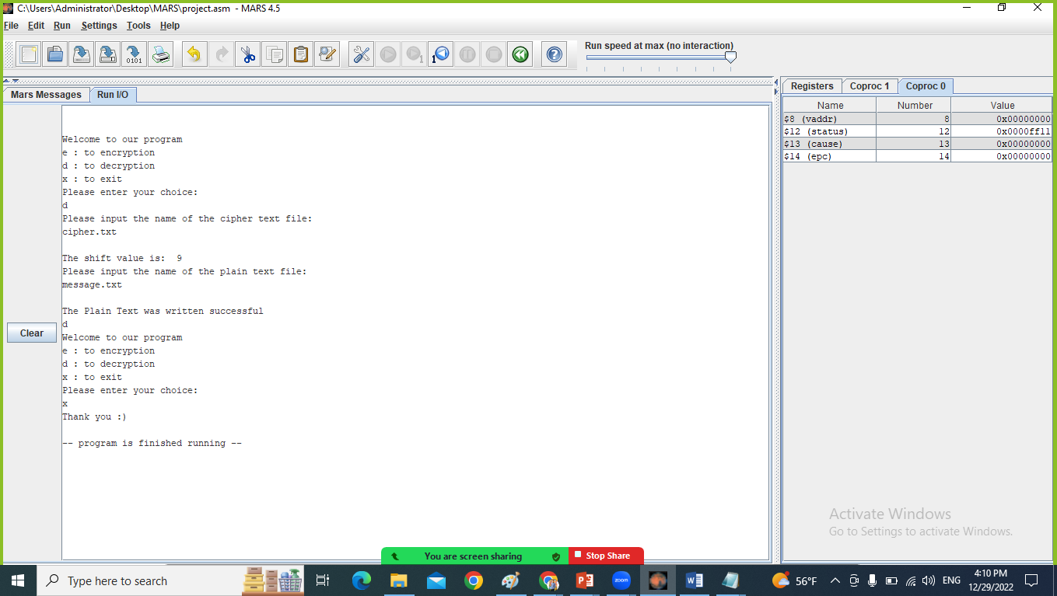

Figure 7: Dencryption test

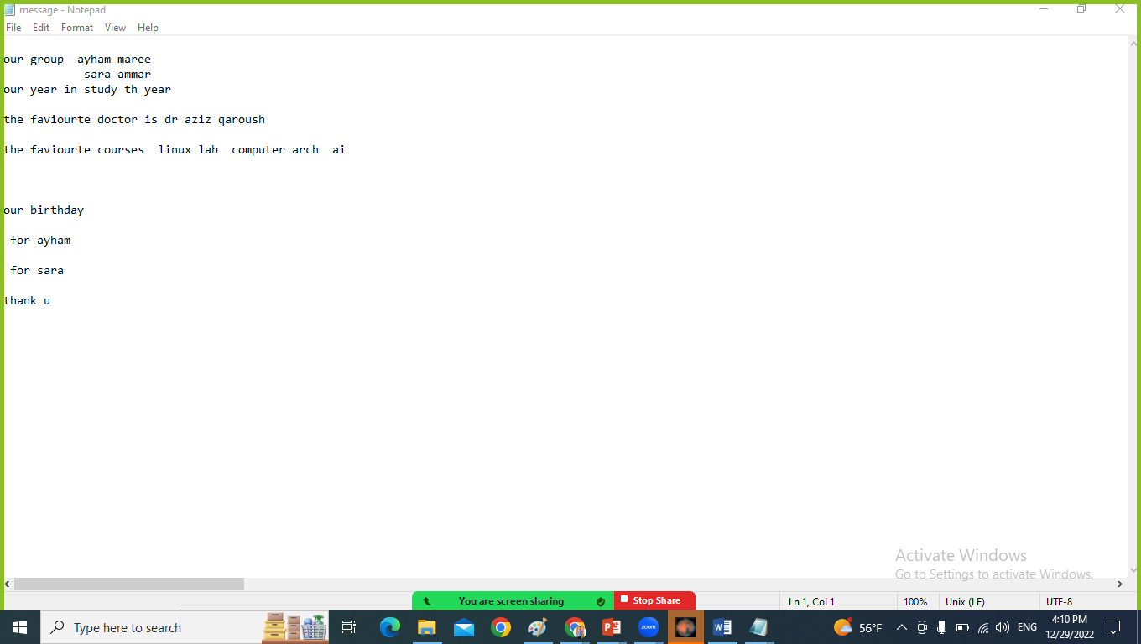

Figure 8: Input Cipher and output message

The shift value from above is: 9 (length of ojerxdacn word).